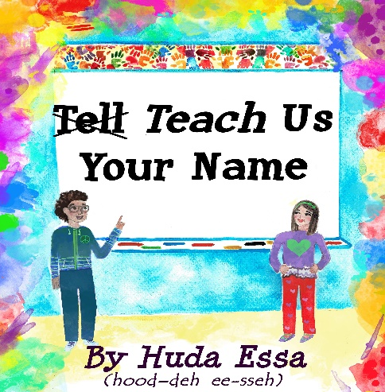
Available on Amazon.com!
Large orders can be purchased at discounted price through author through culturelinksllc.com
Also, contact author through culturelinksllc.com to arrange school assemblies or PD opportunities to support culturally responsive communities!

Supplemental Resource Guide

Some Overarching Themes/Ideas:

- How are people different? (social identities, languages, cultures, etc.)
  - Why is it important to show respect for all people and their many identities?
  - Why is it important that we learn about different identities and cultures?
  - How does this affect everyone? (using empathy, productive communication, building connections, enhanced learning, tolerating ambiguity, etc.)

- What are some ideas that people must teach and learn about each other to better communicate, understand and get along?
  - Ie. Some routines are very common in one culture/country/society but not in other places.
    - Names can serve as an example of this. Some people are named after family older family members. Some people’s last names come from more than one family. Some people’s names have been changed over time due to bias or for some people, they were forced to change their names.

- The main character decides to teach others and is happy that she did. What is something you could teach to others?
  - This can support oral language by allowing for students to use an idea they are confident in. The oral language can then be transferred into written steps and possibly illustrations and a presentation or sharing of the process they are teaching.

- ABC order:
  - The first and last pages of the book are filled with names of children who may not always see their names in books. The names are all in ABC order.
    - This can serve as a model to explain alphabetical order and how to search for words using this idea. They can begin by searching for their name using the ABC order method. This can then be used to search for words in a dictionary or glossary…

- Reading fluency and comprehension:
  - Heeding punctuation to support voice when reading for comprehension
  - Use of italics and other fonts to indicate a different voice
  - Using comprehension of story to show greater expression when reading
  - Various methods to add detail to enhance story; ie. describe feelings, thoughts, actions, etc.
    - Supports teaching of Writing Traits and Writing Process

Sample Talking Points for specific pages:

  - Pg 6: On page 4, the main character nodded her head, yes, when the teacher asked if she was saying her name wrong. Why do you think she did so?
    - Have you or others you know ever done this before? Why? What are the possible short-term and long-term effects of not teaching the correct pronunciation of a name?
    - What benefits can be found from learning how to correctly pronounce the names of others?

  - Pg. 9: What does the character’s mother mean when she says that some names are easy for some people to say but difficult for others to say? How does this apply to people’s names in other countries or who speak languages other than English?
    - ie. Each language has letters and sounds. When we are not fluent in a language, some of those sounds are not always easy to pronounce. Because names come from various languages, this can sometimes make it hard to pronounce some names and to understand words in other languages. – example; in Spanish or Arabic, the R sound is a rolled R. This is not the same as the sound the English R sound makes.

    - The first and last pages of the book are filled with names of students who may not always see their names in books. These names are common names in other countries. This reminds us that what is considered common is relative.
      - If students do not find their own names in those pages, they may see other names that come from the language of their original national origin. Students can search for their own names and if they don’t find them, they can add them to the blank pages in the back of the book OR if there is space to do so, they can squeeze them into a space where they would go along the alphabetical order.

  - Pg. 11-14: Many themes to consider, such as…
    - The importance of getting a name right. People will feel a greater sense of belonging when their name is pronounced correctly.
      - We can learn language sounds from getting used to pronounce names from other languages. Those sounds we learn can help us to one day more fluently speak other languages that use those sounds.
    - Some ethnicities/races/cultural groups, etc are underrepresented or negatively represented in mainstream media/history, etc. and this is something we should be aware of so as to increase our positive communications and success when working with people of all backgrounds.

Continued pg. 11-14 talking points…
    - Why did the main character say it was easier to just allow for people to continue saying her name incorrectly even though she “hated it”?
      - How might this relate to other ideas (ie. Feeling pressured to abandon some cultural traditions, clothing, language, etc. in order to “fit in” and avoid possible criticism)
    - Being sensitive to “jokes” that could hurt someone’s feelings
      - Considering what to say to an individual versus in front of a large group

  - 15-16: What country might they be in? Could this scene possibly be similar to many different countries? Do the people seem outgoing and friendly? Why might you want to go to a place like this? What do friendly gestures look like and how does that help for people feel more welcomed? Why is it important that people feel welcomed?

  - Pg. 15-17: The main character called her parents, Mama and Baba and she called her grandmother, Sittee. What names do you call your relatives? What are different names people use to describe relatives? Ie. Names for parents, grandparents, aunts, uncles, paternal and maternal relatives, etc.

  - Pg. 18: Why did the main character forget about the troubles she had with her name while she was on this trip?

  - Pg. 19: Do you know the meaning of your name? First, middle, last? How was it decided that you would be given this name? Could you find a way to use one of the meanings of one of your names as a reminder of positive ideas? ie. Pride in one’s self, using the meaning to increase positive acts, etc.

  - Pg. 20 – 21: What does it mean to brainstorm? Why is it important to create a plan?
    - Why does the character cross some words out in her written plan? What do you think she was going to finish writing for #5?
    - Would you add or take away any steps? Why or why not?
    - Do you think her plan will work?
    - What mental/emotional preparation will she need in order for her plan to work? Ie. Knowing her efforts are worth it so that she can build up more confidence when speaking with others about it, remembering that most people really do want to know the right way to pronounce our names, considering that it may be a little difficult at first but it will be worth it later and it will become much easier later, considering how this could help others, too (ie. Others who have the same name, others who may be motivated by seeing someone else do it, reminders for people to insist that people TEACH them their names, increasing respect for each other’s names/identities, etc.)

  - Pg. 22: Why does the character explain that she stuck to her plan? Is it always easy to continue with a plan you make? What difficulties might she have had when trying to execute her plan? What are strategies people can use to help them stick to their plans/goals, especially when it may at times feels difficult?
    - What happened after the character felt successful at her task?
    - Why do you think the teacher on this page looks happy?

  - Pg. 24: How does the meaning of the main character’s name reflect on her life? How did she use her name to help her help others? (ie. Using guidance to help others, becoming a teacher, guiding people to take pride in their identities, writing a book, fulfilling a dream, etc)
    - What do you notice about the teacher’s necklace? How do you think her feelings about her name have changed from how she felt about it in the beginning of the story?
    - The boy is showing the class how he wants his name to be said. Can you do that? (Students can show the phonetic spelling to their teacher so that the teacher can review it to be sure the pronunciation key they created really would help them to get the best pronunciation from others. Students can keep this to refer to later when teaching people their name.)

  - Pg. 26- 27: What does taking pride in our names have to do with our identities and supporting diversity and respect for everyone’s differences and similarities?
    - Why is it important that you teach others how to say your name correctly? How will this help you and others both in the short term and long term? Why is it important to do this sooner than later? Consider the plan the main character created to help you create your own ideas for how to teacher others your names.
Created by Huda Essa – culturelinksllc.com

